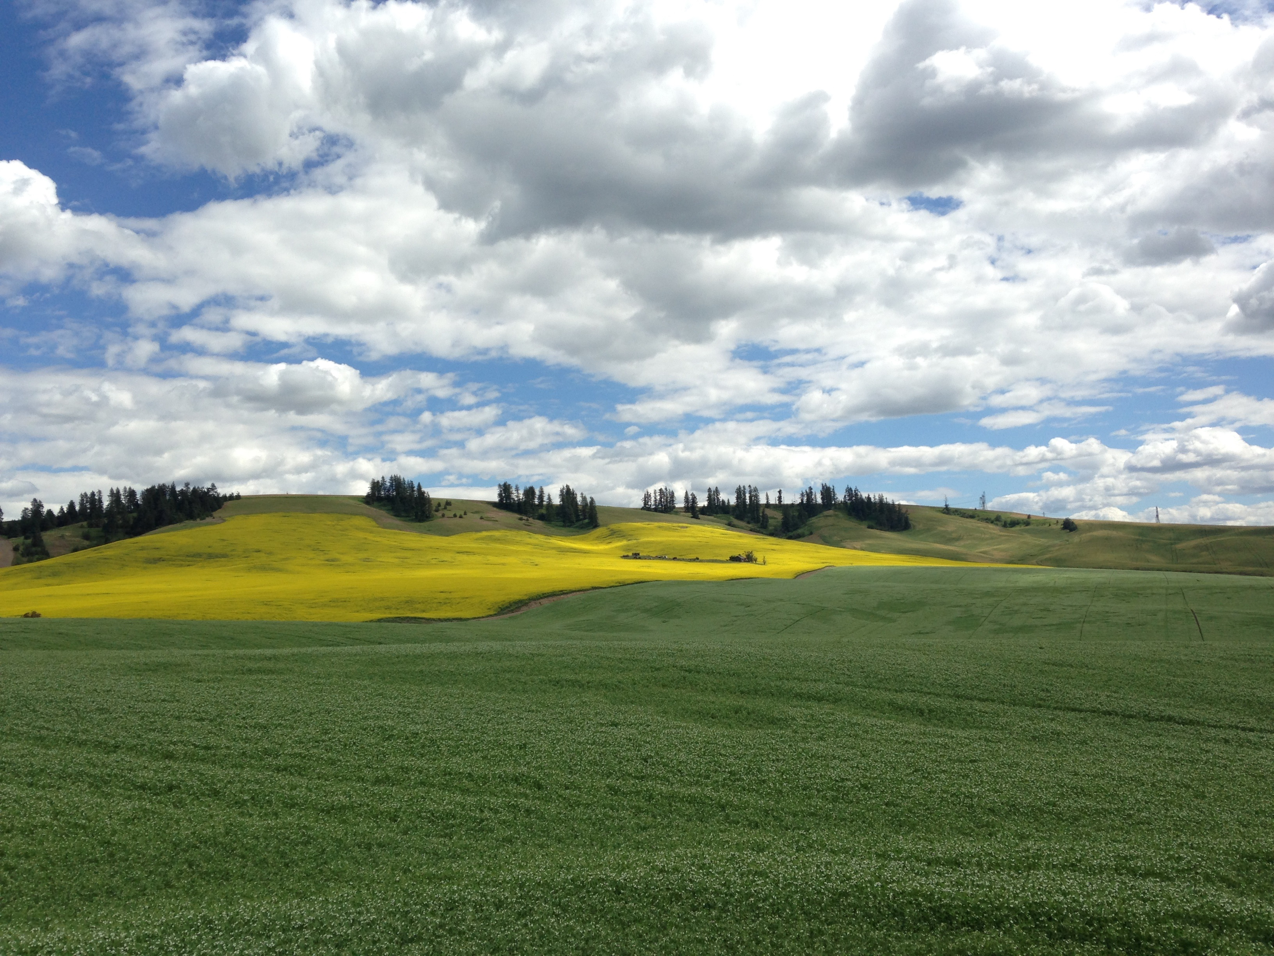
Lincoln County

Conservation District

FY2026 (7/1/26 – 6/30/27)

Annual Work Plan

For More Information Contact: Delaini Disher 509-725-4181 x3053, ddisher@lincolncd.com

Mission of the Lincoln County Conservation District
- To help citizens of Lincoln County protect, conserve, and enhance our natural resources.

Natural Resource Priorities (Based on NRCS West Palouse LWG 2025)
- Cropland/Rangeland: livestock production limitation, pest pressure, terrestrial habitat
- Forestry: degraded plant conditions fire management
1. Program Area: Voluntary Stewardship Program (VSP)

Goal(s):
- Promote the Voluntary Stewardship Program throughout Lincoln County.
- Gather BMP data in Lincoln and inform partners of our actions to protect critical areas.

Funding Source(s): Washington State Conservation Commission
Activities for FY2026/7 | Target Dates | Person  Responsible | Time Required | Estimated Funding | Notes
Community outreach and education on VSP implementation. Collaborate with landowners to implement cost share projects. Gather BMP information and build data set with GIS coordinates for reporting purposes. Conduct water monitoring. | July 1, 2026 to June 30, 2027 | Elsa Bowen, Delaini Disher, and Elayne Hovde-Knudson | 230 days | $125,480 | Remaining funding in biennium
Use Capital Funding to implement BMPs that reduce impacts on critical areas and improve agricultural function. | July 1, 2026 to June 30, 2027 | Delaini Disher, Elayne Hovde-Knudson | 230 days | $40,000 | Remaining funding in biennium

2. Program Area: Palouse Watershed Regional Conservation Partnership Program (RCPP)

Goal(s):
- Partner with Palouse Conservation District to achieve the outcomes of the WRIA 34 RCPP (water quality, soil health, and wildlife habitat).
- Assist producers in WRIA 34 region of Lincoln County to apply for RCPP cost share contracts.

Funding Source(s): USDA National Resources Conservation Service/Washington State Conservation Commission
Activities for FY2027 | Target Dates | Person  Responsible | Time Required | Estimated Funding | Notes
Support partners in WRIA 34 RCPP conservation practices | Ongoing | Elsa Bowen | n/a | $2,000 | Anticipated funding
Promote and enroll WRIA 34 landowners in cost share projects. | Ongoing | Elsa Bowen | n/a | $3,000 | Anticipated funding

3. Program Area: 26-39-NRI

Goal(s):
- Implement natural resource investment projects through cost share program.

Funding Source(s): Washington State Conservation Commission
Activities for FY2026/7 | Target Dates | Person  Responsible | Time Required | Estimated Funding | Notes
Implement cost share program based on priority resource concerns at 80% cost share. | July 1, 2026 to June 30, 2027 | Elsa Bowen and Elayne Hovde-Knudson | 230 days | $6,456.58 | Remaining funding in biennium
4. Program Area: 27-39-IM

Goal(s):
- Promote natural resource conservation efforts and implement natural resource projects to local landowners.
- Perform annual elections and conduct additional District operations.

Funding Source(s): Washington State Conservation Commission
Activities for FY2027 | Target Dates | Person  Responsible | Time Required | Estimated Funding | Notes
Carry out education and outreach activities to promote natural resource conservation and preservation include distributing District newsletters, updating District website, hosting, coordinating wheat week activities, collecting rainfall precipitation data, setting up a county fair outreach booth, completing district board elections, attending area meetings, educational and training opportunities as needed. | July 1, 2026 to June 30, 2027 | All staff | 180 days | $180,000 | Anticipated funding

5. Program Area: 26-27-NR - Adams CD

Goal(s):
- Share administrative and technical resources to support other WA Conservation Districts.
- Administer natural resource investment projects through cost share program.

Funding Source(s): Adams CD, Washington State Conservation Commission
Activities for FY2026/7 | Target Dates | Person  Responsible | Time Required | Estimated Funding | Notes
Assist Adams CD to administer and implement cost share program based on priority resource concerns at 80% cost share. | July 1, 2026 to June 30, 2027 | Elsa Bowen, Elayne Hovde-Knudson and Delaini Disher | 180 days | $10,000 | Anticipated Funding

6. Program Area: 27-39-SFF

Goal(s):
- Identify and address unhealthy forests and build greater community resiliency.
- Coordinate with private landowners for Firewise projects to reduce forest fuel loading in areas deemed a high hazard for wildfire.

Funding Source(s): Washington State Conservation Commission
Activities for FY2027 | Target Dates | Person  Responsible | Time Required | Estimated Funding | Notes
Provides technical assistance to farmers and ranchers to implement climate-smart practices and projects that increase carbon sequestration and reduce greenhouse gas emissions. | July 1, 2026 to June 30, 2027 | Elayne Hovde- Knudson | 180 days | $20,000 | Anticipated Funding

7. Program Area: 27-39-IE

Goal(s):
- Provide technical assistance and cost share to landowners in drought-impacted areas for the purpose of implementing water conservation measures and irrigation efficiencies.

Funding Source(s): Washington State Conservation Commission
Activities for FY2027 | Target Dates | Person  Responsible | Time Required | Estimated Funding | Notes
Provide technical assistance and cost share to eligible landowner(s) to implement a Livestock Water Development | July 1, 2026 to June 30, 2027 | Elsa Bowen, Elayne Hovde-Knudson | 466 days | $900,000 | Anticipated Funding

8. Program Area: 27-39-TP1

Goal(s):
- Provide technical assistance and cost share to landowners in drought-impacted areas for the purpose of implementing water conservation measures and irrigation efficiencies.

Funding Source(s): Natural Resource Conservation Service
Activities for FY2027 | Target Dates | Person  Responsible | Time Required | Estimated Funding | Notes
Perform CRP field checks and conservation plans for Lincoln and Adams County. | July 1, 2026 to June 30, 2027 | Elsa Bowen, Elayne Hovde-Knudson | 92 days | $150,000 | Anticipated Funding

9. Program Area: District Implementation Projects and Community Outreach

Goal(s):
- Implement conservation and preservation BMPs through annual tree sale and a cost share program.
- Provide education and outreach on BMPs for conservation and preservation.
Funding Source(s): Lincoln County Conservation District
Activities for FY2026 | Target Dates | Person  Responsible | Time Required | Estimated Funding | Notes
Provide education and outreach material on conservation and preservation BMPs for soil health, cover crops, water availability and quality, noxious weed control, air quality, erosion prevention, and wildfire fuels reduction. | July 1, 2026 to June 30, 2027 | All staff | 230 days | $10,000
Provide cost share programs on conservation and preservation BMPs for soil health, water availability and quality, noxious weed control, air quality, erosion prevention, and wildfire fuels reduction. | July 1, 2026 to June 30, 2027 | All staff | 230 days | $50,000
Prepare and host annual District Tree Sale | July 1, 2026 to June 30, 2027 | All staff | 90 days | $12,000
Education and permitting of Lincoln County burn permits and administering the rental of a direct seed tillage drill. | July 1, 2026 to June 30, 2027 | All staff | 120 days | $3,000
Static well monitoring for residents in the Hawk Creek area | July 1, 2026 to June 30, 2027 | Dean White | 30 | $1,500

10. Program Area: Columbia Basin FLAG County Municipality Project
Goal(s):
- Create a formal organization to seek alternative water saving projects in the future.

Funding Source(s): Columbia Basin Conservation District
Activities for FY2027 | Target Dates | Person  Responsible | Time Required | Estimated Funding | Notes
Create foundational documents, develop an outreach plan, initiate a small-scale groundwater monitoring program, find alternative projects and network within the region. | Ongoing | Elsa Bowen, Delaini Disher, Dean White | 360 days | $11,500

11. Program Area: USDA Forest Service Community Wildfire Defense Grant
Goal(s):
- Identify high-risk areas and recommend fire prevention projects to lessen impacts of wildland fires on Lincoln County residents and properties.

Funding Source(s): Washington State Dept. of Natural Resources
Activities for FY2027 | Target Dates | Person  Responsible | Time Required | Estimated Funding | Notes
Update a Community Wildfire Protection Plan (CWPP) that is more than 5 years old.  Produce promotional materials based on data collected through past projects to provide landowners in areas of high wildfire risk. | July 1, 2026 to June 30,2027 | Matthew Rosman | 360 days | $10,000 | Remaining Funds in Contract

12. Program Area: 27-39-FH Forest Health
Goal(s):
- Identify high-risk areas and recommend fire prevention projects to lessen impacts of wildland fires on Lincoln County residents and properties.

Funding Source(s): Washington State Conservation Commission
Activities for FY2027 | Target Dates | Person  Responsible | Time Required | Estimated Funding | Notes
Identify residential properties in Lincoln County with high wildfire risk and provide technical assistance enhancing defensible space.  Produce promotional materials based on data collected through past projects to provide landowners in areas of high wildfire risk. | July 1, 2026 to June 30,2027 | Matthew Rosman | 360 days | $75,000 | Anticipated Funding

13. Program Area: Mid-Columbia Basin Drought Preparedness Plan
Goal(s):
- The Mid-Columbia Basin Drought Preparedness Plan prepared by LCCD and the CBSWC will lay the foundation for regional resiliency to drought by identifying projects and actions that will mitigate threats to the planning area posed by climate change and alleviate harms to overburdened communities.

Funding Source(s): Washington State Dept. of Ecology, CBSWC
Activities for FY2027 | Target Dates | Person  Responsible | Time Required | Estimated Funding | Notes
In partnership with the Columbia Basin Sustainable Water Coalition (CBSWC), create a drought preparedness plan to help the Mid-Columbia Basin prepare for and withstand impacts of water level decline. | October 1, 2024 to December 31, 2026 | Elsa Bowen | 729 days | $120,200 | Remaining Funds in Contract

14. Program Area: Inland Northwest Farmers Leading Our United Revolution In Soil Health
(FLOURISH)
Goal(s):
- Support widespread adoption of soil health management systems (SHMS)−specifically cover cropping, interseeding, and cover crop-livestock integration

Funding Source(s): NRCS
Activities for FY2027 | Target Dates | Person  Responsible | Time Required | Estimated Funding | Notes
Assist PCD create a formal, farmer-led group dedicated to demonstrating SHMS that incorporate cover crops and livestock integration with cover crops on a regional scale and disseminate findings to peers, agricultural professionals, and the public. Regular soil sampling and soil sensor maintenance at locations in and around Lincoln County | Dec 2020- Dec 2027 | Delaini Disher, Brean Nieman | 1825 days | $6,000 | Remaining Funds in Contract

15. Program Area: Terry Husseman Grant

Goal(s):
- Remove discarded tires from the Porcupine Bay stream bed and implement riparian plantings on cleared site.

Funding Source(s): Department of Ecology
Activities for FY2027 | Target Dates | Person  Responsible | Time Required | Estimated Funding | Notes
Provide technical assistance to landowners in the Lake Roosevelt area to remove tires from the waterway and stream banks, and to complete riparian restoration planting once the site has been cleared | May 2026-July 2027 | Elsa Bowen, Elayne Hovde-Knudson | 360 days | $80,000 | Anticipated Funding

16. Program Area: Direct Seed

Goal(s):
- Reimburse farmers for adopting no-till farming to improve moisture retention and prevent erosion.

Funding Source(s): Department of Ecology
Activities for FY2027 | Target Dates | Person  Responsible | Time Required | Estimated Funding | Notes
Educate producers on the benefits of converting conventionally tilled ground to no-till, provide resources and cost share to alleviate the financial pressure of adopting a new system and equipment | July 2026-July 2027 | Delaini Disher | 1,080 days | $30,000 | Anticipated Funding

17. Program Area: Hawk Creek Water Quality Improvement

Goal(s):
- Reduce impacts of livestock runoff on the Hawk Creek watershed

Funding Source(s): Department of Ecology
Activities for FY2027 | Target Dates | Person  Responsible | Time Required | Estimated Funding | Notes
Assist landowners in funding exclusion fencing, riparian restoration, hardened crossings, and off-site watering facilities to reduce livestock impact on the watershed | July 2026-July 2027 | Elsa Bowen, Elayne Hovde-Knudson | 360 days | $50,000 | Anticipated Funding

18. Program Area: Little Creek Restoration DIF Project

Goal(s):
- Improve stream quality and reduce bank erosion in Little Creek

Funding Source(s): Department of Ecology
Activities for FY2027 | Target Dates | Person  Responsible | Time Required | Estimated Funding | Notes
Implement in-stream structures (BDA, PALs) and riparian plants along the bank of Little Creek to reduce erosion and improve stream function | July 2026-July 2027 | Delaini Disher | 360 days | $40,000 | Anticipated Funding

19. Program Area: Edwall Floodplains by Design Project
Goal(s):
- Clear impacted stream in Edwall to improve stream quality and prevent further flooding

Funding Source(s): Department of Ecology
Activities for FY2027 | Target Dates | Person  Responsible | Time Required | Estimated Funding | Notes
Dredge a blocked portion of Bluestem Creek that runs through the town of Edwall, has caused significant flooding and continues to prevent the stream from flowing naturally. | July 2026-July 2027 | Elsa Bowen | 360 days | $50,000 | Anticipated Funding

FY2027 Annual Budget


Conservation District
INCOME |  | 2026
 | Grant – VSP | 250,000
 | Grant – Implementation | 180,000
 | Grant – Irrigation Efficiency | 900,000
 | Grant – Task Orders | 150,000
 | Grant – Sustainable Farms & Fields | 20,000
 | Grant – Forest Health | 75,000
 | Grant – Natural Resource Investment | 162,000
 | Grant – FLOURISH | 7,000
 | Grant – MOU Adams CD | 6,000
 | Grant – MOU Columbia Basin CD | 1,500
 | Grant – MOU FLAG Municipalities | 10,000
 | Grant – Cluster Engineering | 40,000
 | Grant – DOE Husseman | 80,000
 | Grant – DOE Direct Seed 4 | 30,000
 | Grant – DOE Hawk Creek | 50,000
 | Grant – DOE Flood Plains By Design | 50,000
 | Grant – DOE DIF Harman Project | 50,000
 | Grant – Innovia Farmer’s Market Grant | 8,000
 | Grant – Drought Plan | 175,000
 | Grant – CWPP | 10,000
 | Interest – Savings Account | 1,800
 | Tree Sale | 50,000
 | Burn Permit | 6,000
 | County Special Assessment | 150,000
 | Misc Surplus Items | 1,500
 | Sales Tax – State Share | 2,500
 | Misc Income | 1,500
 | Total Income | 2,467,800

EXPENSE
 | Communication | 19,000
 | Purchases for Resale | 40,000
 | Office Supplies | 24,000
 | Professional Services | 1,600,000
 | Operation & Lease | 4,000
 | Sales Tax-State Share | 2,000
 | Travel | 20,000
 | Vehicle Fuel Consumed | 5,000
 | Wages & Benefits | 700,000
 | Bank Fees | 500
 | Total Expense | 2,414,500
 | Net Margin | 53,300

