Lincoln - Adams Direct Seed Program
Direct seeding (also called conservation tillage) is a planting and fertilizing option that reduces soil disturbance. This provides better residue retention, increasing moisture retention and preventing erosion. With less soil disturbance, direct seeding mitigates negative environmental impacts from excessive runoff while improving soil productivity.

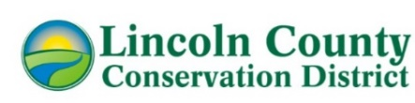
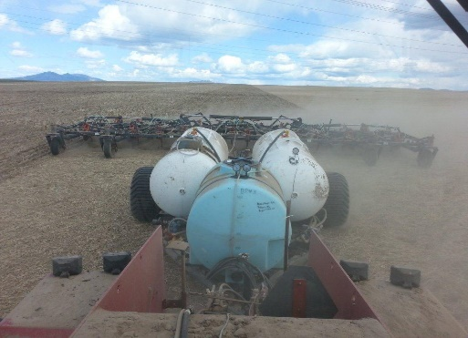
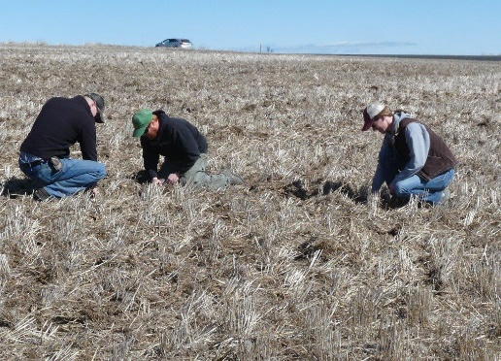
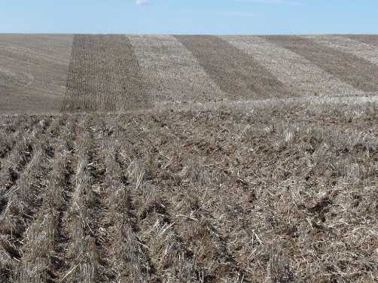
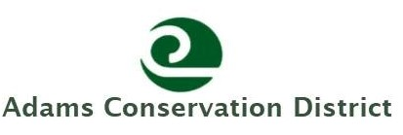
What is the Program?
Through a grant agreement with Adams Conservation District, LCCD provides cost share for equipment rental and custom seeding to eligible producers who implement direct seed tilling.
Basic Cost Share Information
- With a valid cost share agreement, LCCD will provide cost share for up to 3 seedings per producer between July 1, 2026, to June 30, 2029.
- Costs will be reimbursed at a rate of $44.69/acre for up to 250 acres per seeding.
- Producers must RENT a direct seed drill or hire someone to seed for them, then submit an invoice to be reimbursed.
- Fields must be in Adams or Lincoln County
- Producers must be FIRST TIME direct seeders. If you are interested in adopting or trying the practice, this opportunity is for you!
Conservation Benefits
Improve soil health. Keep stubble and organic matter in your field minimizing erosion, increasing organic matter, and reducing moisture loss.
Economic. In the long-term, direct seed can also have economic benefits, through saving fuel, labor time, and wear down of machinery.
Contact US
If you would like more information about this program, please contact Delaini Disher, Lincoln County Conservation District,
509-725-4181 ext. 3053, email ddisher@lincolncd.com, or visit our website Lincolncd.com for more details.

