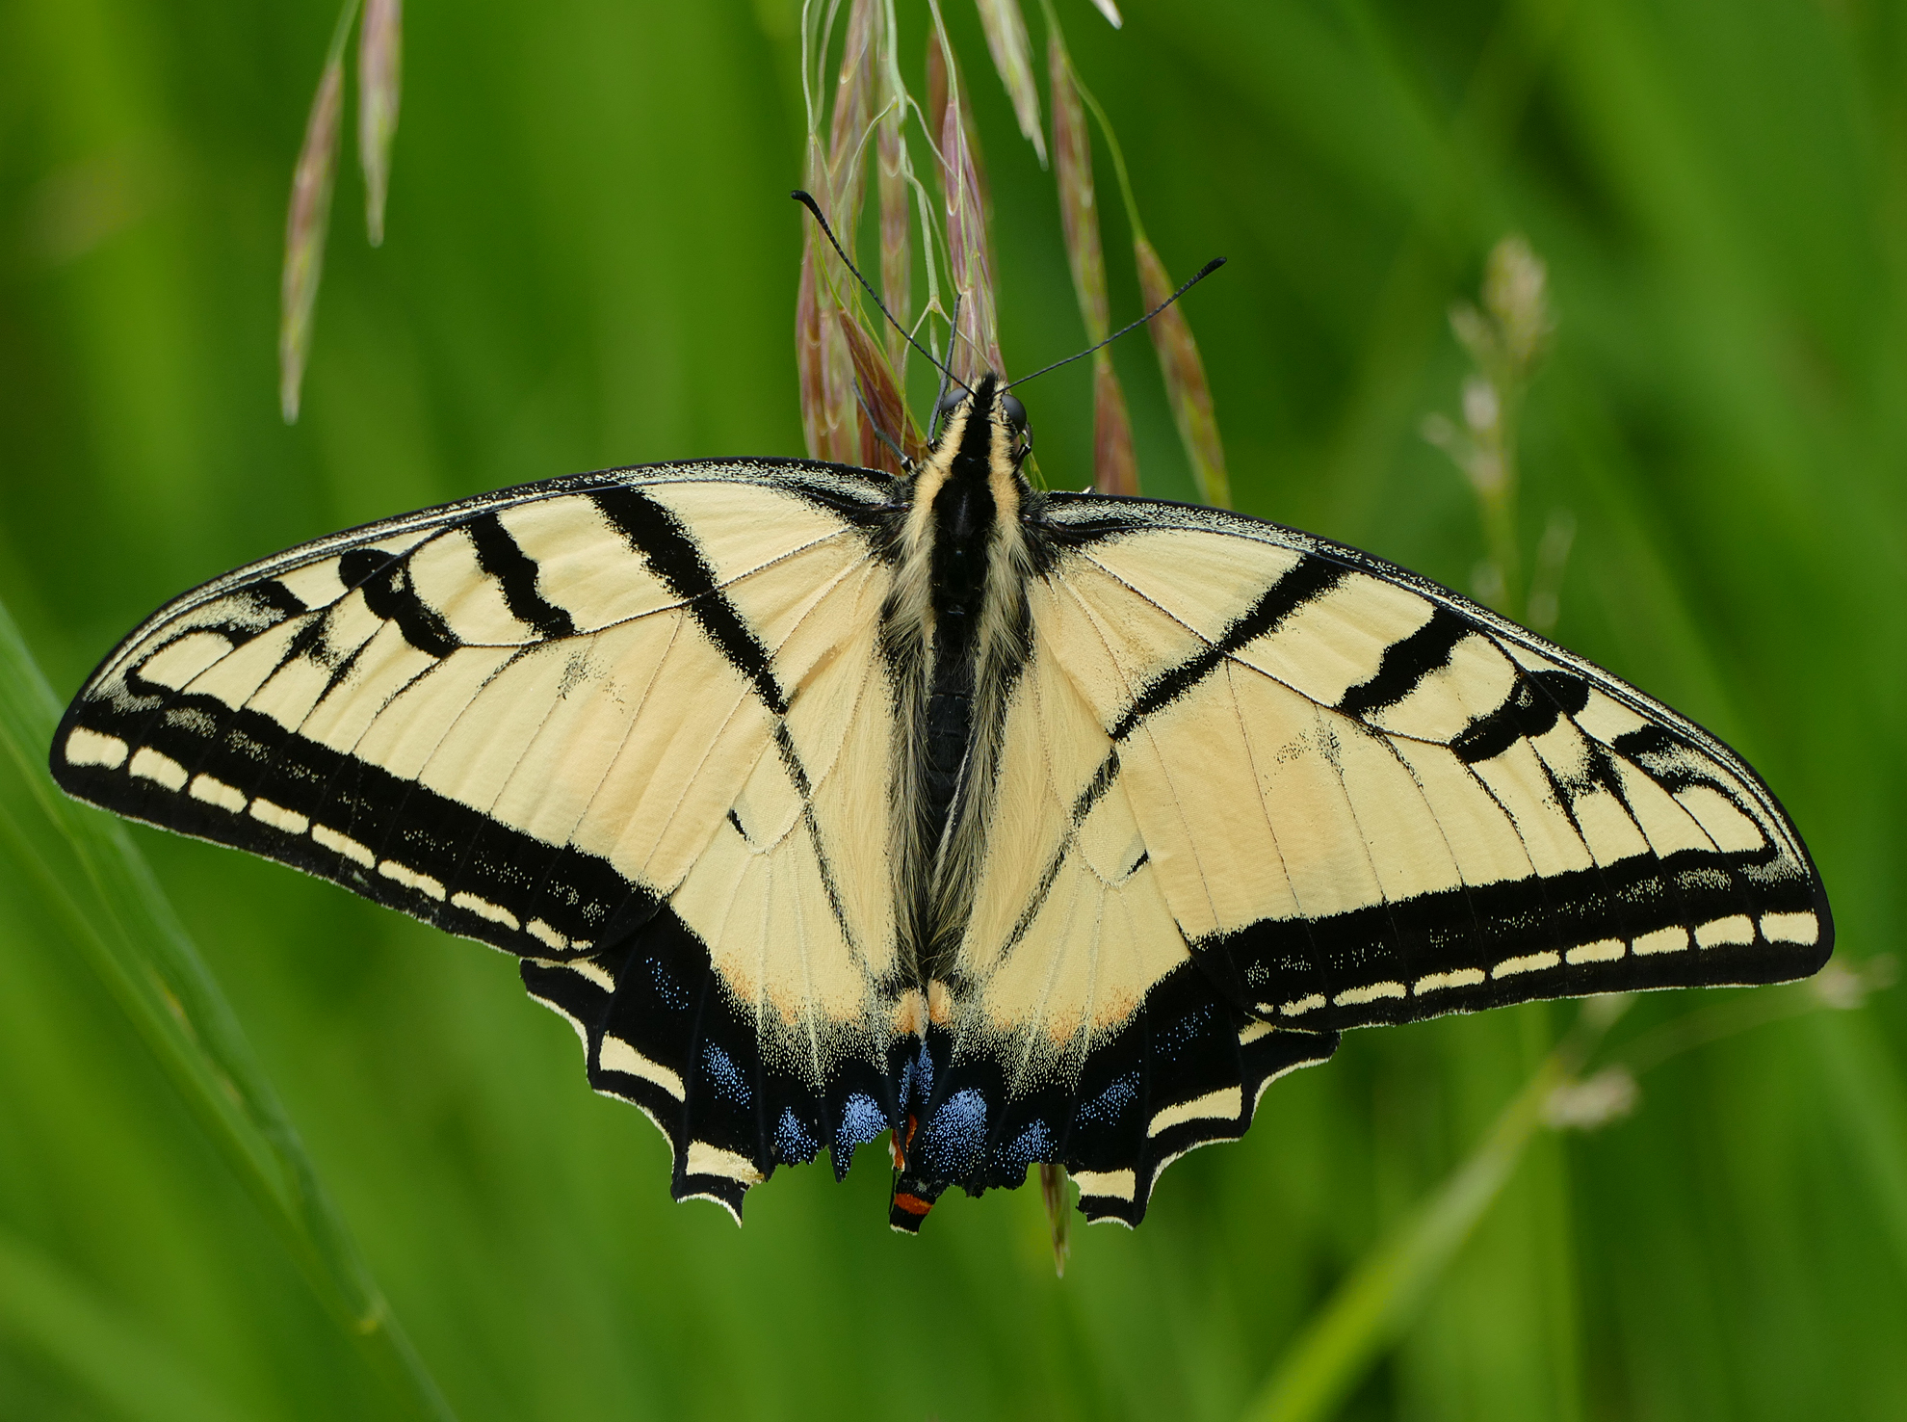
Lincoln County Conservation District

FY2021 (7/1/20 – 6/30/21) Annual Work Plan

For More Information Contact: Kristen Balko, 509-725-4181 x116, kbalko@wadistrict.net

Mission of the Lincoln County Conservation District
- To help citizens of Lincoln County protect, conserve, and enhance our natural resources.

Natural Resource Priorities (Based on NRCS West Palouse LWG 2020)
- Cropland: Soil health and erosion – Organic matter depletion
- Cropland/Rangeland: Water Resources Quality and Quantity - Insufficient and inadequate water
- Forestland: Air quality and degraded plant conditions – Undesirable plant productivity and health, and wildland fire considerations
1. Program Area: Voluntary Stewardship Program (VSP)

Goal(s):
- Promote the Voluntary Stewardship Program throughout Lincoln County.
- Gather BMP data in Lincoln and inform partners of our actions to protect critical areas.
- Administer a cost share program to landowners within the critical resource areas.

Funding Source(s): Washington State Conservation Commission
Activities for FY2021 | Target Dates | Person  Responsible | Time Required | Estimated Funding | Notes
Community outreach and education on VSP implementation. | July 1, 2020 to June 30, 2021 | Elsa Bowen, Val Vissia, and Connor Nikkola | 230 days | $15,000
Gather BMP information and build data set with GIS coordinates for reporting purposes. | July 1, 2020 to June 30, 2021 | Connor Nikkola | 230 days | $15,000
Administer cost-share funds to landowners within critical resource areas. | July 1, 2020 to June 30, 2021 | Connor Nikkola | 230 days | $5,000 | 5 active projects

2. Program Area: Water Quality Program: Direct Seed Implementation

Goal(s):
- Promote the Direct Seed tillage method as a conservation practice and the direct seed cost share program to more producers and acres.
- Improve water quality via a riparian restoration project.

Funding Source(s): Washington State Department of Ecology
Activities for FY2021 | Target Dates | Person  Responsible | Time Required | Estimated Funding | Notes
Conduct outreach campaign to promote direct seed tillage process. | July 1, 2020 to June 30, 2021 | Val Vissia and Kristen Balko | 100 days | $10,000
Partner with Palouse-Rock Lake and Pine Creek CDs to deliver cost share program fund direct seed implementation projects. | July 1, 2020 to June 30, 2021 | Kristen Balko | 180 days | $5,000 | 21 active agreements
Monitor and report the economic benefits of direct seed tillage implementation and enroll producers in the Farmed Smart program. | July 1, 2020 to June 30, 2021 | Kristen Balko and Elsa Bowen | 100 days | $500
Evaluate BMPs and coordinate planning activities for up to 4 miles of riparian restoration project. | July 1, 2020 to June 30, 2021 | Kristen Balko and Elsa Bowen | 30 days | $500 | 3 miles of riparian completed
3. Program Area: Lincoln County Sustainable Water Supply Program

Goal(s):
- Collect water level data and build a water level geospatial database for Lincoln County.
- Use the water level database to identify water level changes and build a long-term monitoring effort.

Funding Source(s): Washington State Department of Ecology, Office of the Columbia River
Activities for FY2021 | Target Dates | Person  Responsible | Time Required | Estimated Funding | Notes
Collect well water level data and develop an updated well water level database. | July 1, 2020 to June 30, 2021 | Dean White, Val Vissia and Kristen Balko | 180 days | $10,000 | 70 wells monitored monthly
Produce and submit a final project report describing groundwater level conditions and recommendations for future water level data collection and resource management. | July 1, 2020 to June 30, 2021 | Dean White | 60 days | $5,000

4. Program Area: Regional Sustainable Water Supply Program
Goal(s):
- Collaborate and support regional partners to address groundwater supply issues.
- Influence and inform public and policy makers to direct resource for groundwater solutions.

Funding Source(s): United States Bureau of Reclamation
Activities for FY2021 | Target Dates | Person  Responsible | Time Required | Estimated Funding | Notes
Collect, and train partners to collect, well water level measurements to add data on regional ground water supply. | July 1, 2020 to June 30, 2021 | Dean White | 180 days | $5,000 | Anticipated funding
Assist partners with outreach campaign to educate public and policy makers on groundwater supply and management concerns. | July 1, 2020 to June 30, 2021 | Val Vissia | 60 days | $5,000 | Anticipated funding
Collaborate with regional partners to seek funds to address groundwater supply and management concerns. | July 1, 2020 to June 30, 2021 | Kristen Balko and Elsa Bowen | 60 days | $5,000 | Anticipated funding

5. Program Area: Mielke WRP Wetland and Riparian Restoration

Goal(s):
- Work with program partners on the restoration of wetland and riparian areas in the Pend Oreille River Watershed (WRIA 62).

Funding Source(s): Washington State Department of Ecology
Activities for FY2021 | Target Dates | Person  Responsible | Time Required | Estimated Funding | Notes
Assist partners in acquiring necessary permits and engineering plan for earthwork construction. | July 1, 2020 to June 30, 2021 | Elsa Bowen and Kristen Balko | 90 days | $5,000
Assist partners in planting vegetation along riparian and wet meadow, and monitor plant survivability and water quality improvements after project implementation. | July 1, 2020 to June 30, 2021 | Elsa Bowen and Kristen Balko | 60 days | $7,500

6. Program Area: Forest Health and Wildfire Fuels Reduction

Goal(s):
- Promote forestry practices to reduce wildfire risk and perform home assessments in targeted Wildland Urban Interface (WUI) areas.
- Educate the public and promote LCCD and partner cost share opportunities.

Funding Source(s): Washington State Department of Natural Resources/Council of Western State Foresters
Activities for FY2021 | Target Dates | Person  Responsible | Time Required | Estimated Funding | Notes
Conduct outreach campaign to educate the public on forest health and wildfire risk in targeted WUI areas. | July 1, 2020 to June 30, 2021 | Val Vissia and Connor Nikkola | 60 days | $2,000
Perform home assessments and provide technical assistance to landowners and partners to build Firewise Community projects. | July 1, 2020 to June 30, 2021 | Val Vissia and Connor Nikkola | 60 days | $5,000 | 1 Firewise Community established
7. Program Area: Wildfire prevention and recovery
Goal(s):
- Coordinate with landowners to conduct pro-active wildfire fuels reduction treatments in targeted Wildland Urban Interface (WUI) communities.
- Administer fuels reduction cost share program.
Funding Source(s): Washington State Emergency Management Division/FEMA
Activities for FY2021 | Target Dates | Person  Responsible | Time Required | Estimated Funding | Notes
Perform property assessments and develop individualized fire mitigation plans for landowners in targeted WUI communities. | July 1, 2020 to June 30, 2021 | Elsa Bowen, Val Vissia, and Conner Nikkola | 60 days | $10,000 | Anticipated funding
Conduct outreach campaign and administer fuels reduction cost share program. | July 1, 2020 to June 30, 2021 | Val Vissia and Kristen Balko | 60 days | $5,000 | Anticipated funding
Provide technical assistance to landowners and partners to perform targeted mitigation projects. | July 1, 2020 to June 30, 2021 | Val Vissia and Connor Nikkola | 30 days | $5,000 | Anticipated funding
Support landowners after implementation to fulfill monitoring and reporting requirements. | July 1, 2020 to June 30, 2021 | All staff | 10 days | $2,000 | Anticipated funding
8. Program Area: Palouse Watershed Regional Conservation Partnership Program (RCPP)

Goal(s):
- Partner with Palouse Conservation District to achieve the outcomes of the WRIA 34 RCPP (water quality, soil health, and wildlife habitat).
- Assist producers in WRIA 34 region of Lincoln County to apply for RCPP cost share contracts.

Funding Source(s): USDA National Resources Conservation Service/Washington State Conservation Commission
Activities for FY2021 | Target Dates | Person  Responsible | Time Required | Estimated Funding | Notes
Support partners in WRIA 34 RCPP conservation practices | July 1, 2020 to June 30, 2021 | Kristen Balko and Elsa Bowen | 10 days | $2,000 | Anticipated funding
Promote and enroll WRIA 34 landowners in cost share projects. | July 1, 2020 to June 30, 2021 | Elsa Bowen and Kristen Balko | 30 days | $3,000 | Anticipated funding

9. Program Area: 20-39-NR

Goal(s):
- Implement natural resource investment projects through cost share program.

Funding Source(s): Washington State Conservation Commission
Activities for FY2021 | Target Dates | Person  Responsible | Time Required | Estimated Funding | Notes
Implement cost share program based on priority resource concerns at 75% cost share. | July 1, 2020 to June 30, 2021 | Elsa Bowen and Kristen Balko | 230 days | $15,000 | 2 active projects
10. Program Area: 21-39-IM

Goal(s):
- Promote natural resource conservation efforts and implement natural resource projects to local landowners.
- Perform annual elections and conduct additional District operations.

Funding Source(s): Washington State Conservation Commission/WACS Mini Grant
Activities for FY2021 | Target Dates | Person  Responsible | Time Required | Estimated Funding | Notes
Carry out education and outreach activities to promote natural resource conservation and preservation include distributing District newsletters, updating District website, hosting annual 6th grade day, coordinating wheat week activities, collecting rainfall precipitation data, setting up a county fair outreach booth, coordinating with partners to carry out the county’s Hazard Mitigation Plan and attending area meetings, educational and training opportunities as needed. | July 1, 2020 to June 30, 2021 | All staff | 180 days | $25,000 | Anticipated funding
Hold an annual district supervisor election | January 1, 2021 to March 31, 2021 | Val Vissia | 60 days | $500 | Anticipated funding
Provide outreach and education for WA state natural resource priorities, such as salmon and orca recovery. | July 1, 2020 to June 30, 2021 | All staff | 180 days | $5,000 | Anticipated funding
11. Program Area: 20-27-NR

Goal(s):
- Share administrative and technical resources to support other WA Conservation Districts.
- Administer natural resource investment projects through cost share program.

Funding Source(s): Washington State Conservation Commission
Activities for FY2021 | Target Dates | Person  Responsible | Time Required | Estimated Funding | Notes
Administer and implement cost share program based on priority resource concerns at 75% cost share. | July 1, 2020 to June 30, 2021 | Elsa Bowen, Connor Nikkola and Kristen Balko | 180 days | $2,000 | 1 active project

12. Program Area: Verle Kaiser Soil Education Tour

Goal(s):
- Education and outreach to area public school students on direct seed tillage practices and benefits

Funding Source(s): Washington State University’s Kaiser Conservation Endowment
Activities for FY2021 | Target Dates | Person  Responsible | Time Required | Estimated Funding | Notes
Coordinate and host educational program on conservation practices for Lincoln County 4th graders. | February 1, 2021 to May 31, 2021 | Val Vissia | 90 days | $300 | Anticipated funding
Partner with local area producers to host a tour and presentation about soil health and erosion. | February 1, 2021 to May 31, 2021 | Val Vissia | 90 days | $450 | Anticipated funding

13. Program Area: WRP Tree Planting
Goal(s):
- Provide administrative coordination to schedule and complete tree planting projects.
- Assist NRCS staff with planting 5,000 trees along Crab Creek WRP.

Funding Source(s): Natural Resource Conservation Service
Activities for FY2021 | Target Dates | Person  Responsible | Time Required | Estimated Funding | Notes
Coordinate NRCS staff, material suppliers, landowners, DNR correction crew to schedule tree planting projects. | November 1, 2020 to April 31, 2021 | Elsa Bowen | 30 days | $5,000
Assist NRCS staff to implement the establishment of 5,000 trees and shrubs along Crab Creek WRP. | March 15, 2021 to May 15, 2021 | All staff | 30 days | $10,000

14. Program Area: Wetland Removal Mitigation
Goal(s):
- Provide administrative support to local construction projects impacting natural resources.
- Provide compensatory wetland mitigation as needed.

Funding Source(s): Lincoln County Department of Public Works
Activities for FY2021 | Target Dates | Person  Responsible | Time Required | Estimated Funding | Notes
Provide administrative support for road construction projects in Lincoln County | July 1, 2020 to June 30, 2021 | Elsa Bowen and Kristen Balko | 30 days | $2,000 | Anticipated funding
Establish vegetation in alternate locations to compensate for plants removed due to county construction projects. | July 1, 2020 to June 30, 2021 | All staff | 10 days | $7,500 | Anticipated funding

15. Program Area: District Implementation Projects and Community Outreach

Goal(s):
- Implement conservation and preservation BMPs through annual tree sale and a cost share program.
- Provide education and outreach on BMPs for conservation and preservation.
Funding Source(s): Lincoln County Conservation District
Activities for FY2021 | Target Dates | Person  Responsible | Time Required | Estimated Funding | Notes
Provide education and outreach material on conservation and preservation BMPs for soil health, cover crops, water availability and quality, noxious weed control, air quality, erosion prevention, and wildfire fuels reduction. | July 1, 2020 to June 30, 2021 | All staff | 230 days | $10,000
Provide cost share programs on conservation and preservation BMPs for soil health, water availability and quality, noxious weed control, air quality, erosion prevention, and wildfire fuels reduction. | July 1, 2020 to June 30, 2021 | All staff | 230 days | $10,000 | 5 active projects
Prepare and host annual District Tree Sale | January 1, 2021 to March 30, 2021 | All staff | 90 days | $12,000
Education and permitting of Lincoln County burn permits and administering the rental of a direct seed tillage drill. | July 1, 2020 to June 30, 2021 | All staff | 120 days | $5,000

16. Program Area: NRCS Task Orders
Goal(s):
- Support Natural Resource partners with federal and state task order compliance

Funding Source(s): Washington State Conservation Commission/Natural Resource Conservation Service
Activities for FY2021 | Target Dates | Person  Responsible | Time Required | Estimated Funding | Notes
Assist NRCS with the CRP sign up process for producers in Lincoln and Adams Counties. | July 1, 2020 to October 31, 2020 | All staff | 90 days | $30,000
Assist partners with the administration of additional natural resource practices. | July 1, 2020 to June 30, 2021 | All staff | 90 days | $15,000 | Anticipated funding
Provide education to area producers regarding federal and state policies and practices | July 1, 2020 to June 30, 2021 | Elsa Bowen and Val Vissia | 230 days | $10,000

17. Program Area: Lincoln County Regionalization Program

Goal(s):
- Provide technical and administrative support to Lincoln County’s regionalization efforts to improve public utility efficiencies.
- Provide outreach to county residents regarding the quality and quantity of their water and wastewater systems

Funding Source(s): Rural Community Assistance Corporation/Washington State Department of Health
Activities for FY2021 | Target Dates | Person  Responsible | Time Required | Estimated Funding | Notes
Partner with county agencies and organizations advance regionalization efforts to improve water and wastewater systems. | July 1, 2020 to June 30, 2021 | All staff | 60 days | $5,000
Provide staff support to educate residents on regionalization efforts and on the status of their water and wastewater systems. | July 1, 2020 to June 30, 2021 | All staff | 60 days | $5,000

FY2021 Annual Budget

Conservation District

(District budget for FY2020 (7/1/20 – 6/30/21)
2020 Lincoln County Conservation District Budget | Approved 12/11/19
INCOME
Grant- BLM Roadside Fuel Breaks | 55,000
Grant-NFWF CWMA Weed Mapping | 36,000
Grant-Turnbull Agreement | 11,000
Grant-WaterSMART | 50,000
Grant-Static Well Monitoring | 50,000
Grant- Creating Firewise Networking (FAC) | 5,200
Grant-VSP | 200,000
Grant-18-39-IM | 12,000
Grant-19-39-IM | 60,000
Grant-20-39-IM | 40,000
Grant-21-39-IM | 60,000
Grant-18-39-NR | 17,500
Grant-20-39-NR | 700
Grant-20-39-CR | 10,000
Grant-21-39-CR | 10,000
Grant-21-39-BA | 12,500
Grant-20-27-IM Adams CD | 2,800
Grant-20-27-NR Adams CD | 5,000
Grant-Cluster Engineering | 12,000
Grant-Verle Kaiser (Direct Seed Tour Kids) | 751
Grant - WA SAO File Archive | 5,500
Interest-Savings Account | 1,400
Equipment & vehicles rentals | 10
Tree Sales | 80,000
Rain Gauges | 100
Burn Permits | 5,000
County Special Assessment | 150,000
Misc Surplus Items | 300
Sales Tax-State Share | 1,100
Misc Income | 1,500
Grant- Direct Seed DOE | 200,000
Grant- Mielke WRP DOE | 125,000
Grant- RCPP WRIA 34 | 1,000
Total Income | 1,221,361
Expenses
Assessment Collection Fee | 14,000
Communication | 17,000
Misc | 850
Purchases for Resale | 32,000
Office Supplies | 24,000
Professional Services | 500,000
Operation & Lease | 12,000
Sales Tax-State Share | 6,000
Travel | 22,000
Vehicle Fuel Consumed | 10,000
Wages & Benefits | 445,000
Bank Fees | 300
Office Rent | 15,000
Total Expenses | 1,098,150
Net Margin | 123,211

